The Endocrine System
What Is the Endocrine System?
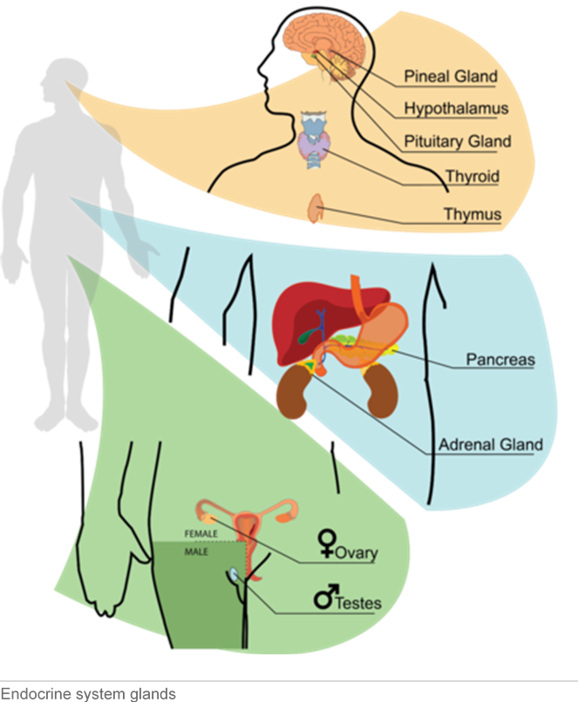
The endocrine system is a system of glands that release chemical messenger molecules into the blood stream. The messenger molecules are called hormones. Hormones act slowly compared with the rapid transmission of electrical impulses of the nervous system. Endocrine hormones must travel through the bloodstream to the cells they control, and this takes time. On the other hand, because endocrine hormones are released into the bloodstream, they travel to cells everywhere in the body. For a good visual introduction to the endocrine system, watch this short video: http://www.youtube.com/watch?v=gjmS4_7kvDM.

Glands of the Endocrine System
An endocrine gland is a gland that secretes hormones into the bloodstream for transport around the body (instead of secreting hormones locally, like sweat glands in the skin). Major glands of the endocrine system are shown in the Figure below. The glands are the same in males and females except for the ovaries and testes.

Hypothalamus
The hypothalamus is actually part of the brain, but it also secretes hormones. Some of its hormones go directly to the pituitary gland in the endocrine system. These hypothalamus hormones tell the pituitary to either secrete or stop secreting its hormones. In this way, the hypothalamus provides a link between the nervous and endocrine systems.
The hypothalamus also produces hormones that directly regulate body processes. For example, it produces antidiuretic hormone. This hormone travels to the kidneys and stimulates them to conserve water by producing more concentrated urine.

Pituitary Gland
The pea-sized pituitary gland is just below the hypothalamus and attached directly to it. The pituitary receives hormones from the hypothalamus. It also secretes its own hormones. Most pituitary hormones control other endocrine glands. That’s why the pituitary gland is called the “master gland” of the endocrine system. The Table below lists several pituitary hormones and what they do.
Pituitary Hormone | Target  Glands/Cells | Effects(s)
Adrenocorticotropic hormone (ACTH) | adrenal glands | Stimulates the cortex (outer layer) of the adrenal glands to secrete their hormones
Thyroid-stimulating hormone (TSH) | thyroid gland | Stimulates the thyroid gland to secrete its hormones
Growth hormone (GH) | body cells | Stimulates body cells to make proteins and grow
Follicle-stimulating hormone (FSH) | ovaries or testes | Stimulates the ovaries to develop mature  eggs; stimulates the testes to produce sperm
Luteinizing hormone (LH) | ovaries or testes | Stimulates the ovaries or testes to secrete sex hormones; stimulates the ovaries to release eggs
Prolactin (PRL) | mammary  glands | Stimulates the mammary glands to produce milk

Other Endocrine Glands
There are several other endocrine glands. Find them in the Figure above as you read about them below.
The thyroid gland is a relatively large gland in the neck. Hormones secreted by the thyroid gland include thyroxin. Thyroxin increases the rate of metabolism in cells throughout the body.
The pancreas is a large gland located near the stomach. Hormones secreted by the pancreas include insulin. Insulin helps cells absorb glucose from the blood. It also stimulates the liver to take up and store excess glucose.
The two adrenal glands are glands located just above the kidneys. Each adrenal gland has an outer layer (cortex) and inner layer (medulla) that secrete different hormones. The hormone adrenaline is secreted by the inner layer. It prepares the body to respond to emergencies. For example, it increases the amount of oxygen and glucose going to the muscles.
The gonads are glands that secrete sex hormones. Male gonads are called testes. They secrete the male sex hormone testosterone. The female gonads are called ovaries. They secrete the female sex hormone estrogen. Sex hormones stimulate the changes of puberty. They also control the production of sperm or eggs by the gonads.

How Endocrine Hormones Work
Endocrine hormones travel throughout the body in the blood. However, each endocrine hormone affects only certain cells, called target cells.

Hormones and Target Cells
A target cell is the type of cell on which a given endocrine hormone has an effect. A target cell is affected by a given hormone because it has proteins on its surface to which the hormone can bind. When the hormone binds to target cell proteins, it causes changes inside the cell. For example, binding of the hormone might cause the release of enzymes inside the cell. The enzymes then influence cell processes.

Feedback Loops
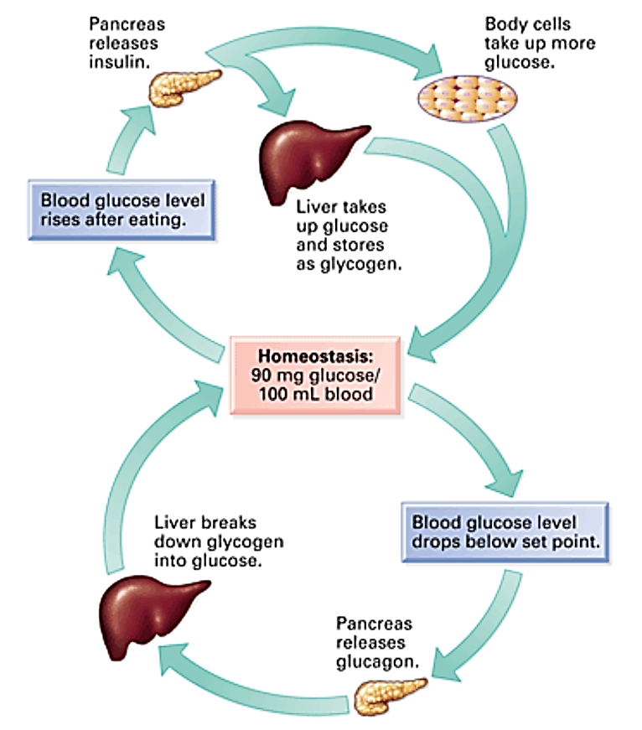
Endocrine hormones control many cell activities, so they are very important for homeostasis. But what controls the hormones? Most endocrine hormones are controlled by feedback loops. In a feedback loop, the hormone produced by a gland feeds back to control its own production by the gland. A feedback loop can be negative or positive. Most endocrine hormones are controlled by negative feedback loops. .Negative feedback occurs when rising levels of a hormone feed back to decrease secretion of the hormone or when falling levels of the hormone feed back to increase its secretion.
You can see an example of a feedback loop in the figure below. It shows how the level of glucose in the bloodstream is maintained at a reasonably constant level (homeostasis). The hormones responsible for this are Insulin and glucagon, both released by the pancreas. In reality, the feedback mechanisms in the body are more complex than shown in this simple diagram.

Lesson Review Questions

Recall
- What is the endocrine system?

- What is/are the key hormone(s) released by each of the following glands and what is the main action of that hormone
GLAND | HOREMONE | ACTION
Pituitary | Growth hormone
 | Tyroid-stimulating hormone
Testes (male gonad)
Adrenal gland
Pancreas
Ovaries

- Given that the nervous system and the endocrine system both act as control systems of the body - what are the key differences between the nervous system and the endocrine system?

- How are the nervous and endocrine systems similar?

- Define target cell.

Apply Concepts
4. Diabetes is a disease where the secretion of insulin by the pancreases is affected – often by not secreting enough insulin. How would this affect the body? How this disease might be treated

Think Critically
- Explain why the pituitary gland is considered the master gland of the endocrine system.

